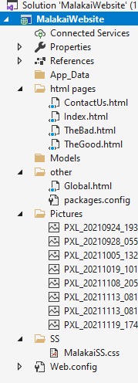**1.8 I can store and retrieve files effectively, in line with local guidelines and** **conventions where available.**  
Within Visual Studio I have all of my pages saved in the appropriate folders:

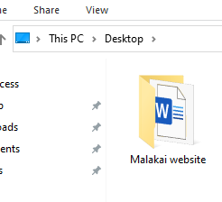I have the project saved in a folder which is saved onto my computer desktop. This makes it clearly identifiable and very easy to access. I have no information on my website which is in the public domain, or which uses anyone’s personal data (other than the name of our cat!)